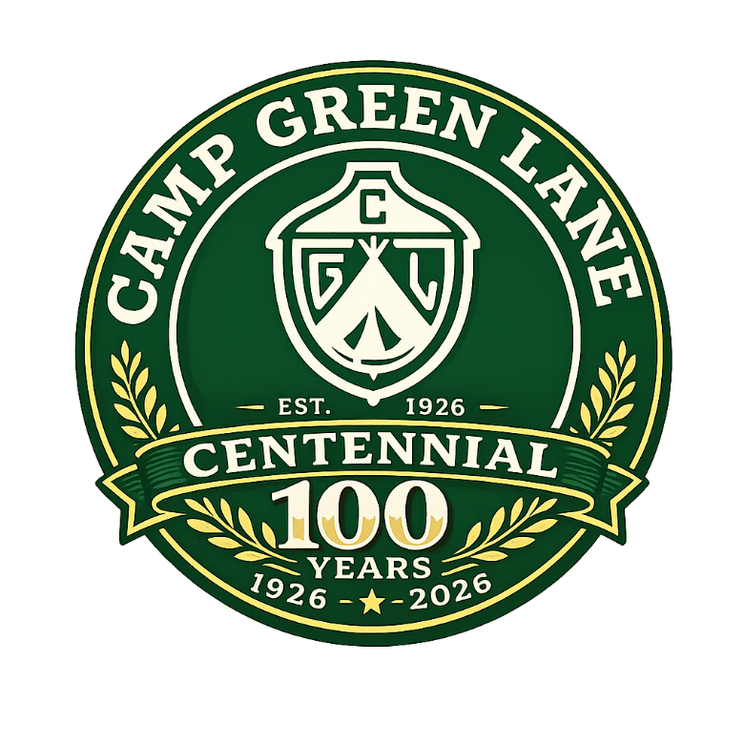
For 100 years, Camp Green Lane has been more than a summer camp — it’s been a second home, a lifelong friendship factory, a place where memories were made, and a place where happiness counts.
As we celebrate our 100th Anniversary, we’re creating a commemorative video featuring the voices of the people who made Green Lane what it is — YOU.
If you’re a former camper, counselor, or staff member, we’d love for you to record a short video message and share your Green Lane story.

🎬 What to Say (Keep it 30–60 seconds)
You can answer one or more of these prompts:
- What year(s) did you attend Camp Green Lane?
- What’s your favorite Green Lane memory?
- How did camp impact your life?
- Who did you meet there that you’re still connected with?
- What does “Green Lane” mean to you today?
- Finish this sentence: “Camp Green Lane taught me…”
Feel free to keep it heartfelt, funny, reflective — whatever feels authentic to you.

📱 How to Film (Simple Cell Phone Instructions)
We want your video to look and sound great! Please follow these guidelines:

1️⃣ Use Your Phone — But Film Horizontally
Hold your phone sideways (landscape orientation) — not vertical.

2️⃣ Good Lighting Is Everything
- Face a window or natural light.
- Avoid bright light behind you (no backlighting).
- Make sure your face is clearly visible.

3️⃣ Quiet Location
- Turn off TVs, music, fans, or air conditioners.
- Avoid windy outdoor spots.
- Speak clearly and at a normal pace.

4️⃣ Stable Shot
- Prop your phone on a table or steady surface.
- Avoid holding it in your hand if possible.
- Frame yourself from mid-chest up.

5️⃣ Look at the Camera
Look at the lens (not at yourself on the screen).

6️⃣ Keep It Under 1 Minute
Short, heartfelt messages are perfect.

📤 How to Submit
Please send your video file to:
📧CGL100Years@gmail.com
or upload here:
Submission deadline: July 15, 2026

💚 Help Us Celebrate 100 Years
For a century, Camp Green Lane has shaped lives, built friendships, and created traditions that span generations.
Now it’s your turn to be part of its history.
We can’t wait to hear your story.

